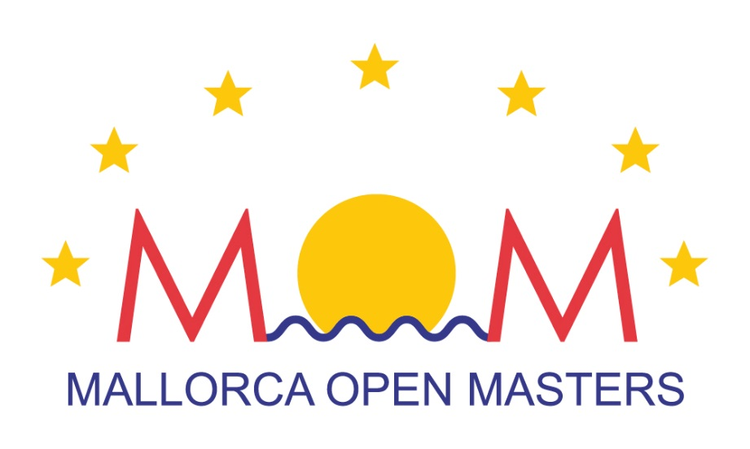
RULES OF
XXII MALLORCA OPEN MASTERS - MOM
2 and 3 April 2016

The Mallorca Open Masters - MOM is a swimming trophy organized by the Balearic Swimming Federation and club Esports Màsters "Esmas".
This trophy is for all the swimmers federated in the category Master, whatever their nationality.

The trophy will be held over two days, Saturday afternoon and Sunday morning, with the following characteristics:
Place: Piscinas Municipales SON HUGO
Timer: Electronic timer
Pool: 25 m. Indoor 8 Lanes

1. AGES GROUPS
20+ 20-24 years (born 1996-92): PRE-MASTER
25+ 25-29 years (born 1991-87)
30+ 30-34 years (born 1986-82)
35+ 35-39 years (born 1981-77)
40+ 40-44 years (born 1976-72)
45+ 45-49 years (born 1971-67)
50+ 50-54 years (born 1966-62)
55+ 55-59 years (born 1961-57)
60+ 60-64 years (born 1956-52)
65+ 65-69 years (born 1951-47)
70+ 70-74 years (born 1946-42)
75+ 75-79 years (born 1941-37)
80+ 80-84 years (born 1936-32)
85+ 85-89 years (born 1931-27)
90+ 90-94 years (born 1926-22)
95+ 95-99 years (born 1921-17)
More than 100 years (born 1916 and earlier)

2. COMPETITION PROGRAM
First session: Saturday 16:00 hours.
1 - 400 m. Freestyle Men
2 - 400 m. Freestyle Women
3 - 50 m. Fly Men
4 - 50 m. Fly Women.
5 - 100 m. Breast Men.
6 - 100 m. Breast Women
7 - .50 m. Freestyle Men
8 - .50 m. Freestyle Women
9 - 100 m. Back Men
10 - 100 m. Back Women
11 - 4x50 m. Freestyle Men
12 - 4x50 m. Freestyle Women.
13 - 4x50 m. Freestyle Mixed
Second session: Sunday 09:00 hours.
14 - 50 m. Back Men
15 - 50 m. Back Women
16 - 100 m. Fly Men
17 - 100 m. Fly Women
18 - 50 m. Breast Men
19 - 50 m. Breast Women
20 - 100 m. Freestyle Men
21 - 100 m. Freestyle Women
22 - 100 m. Ind. Medley Men.
23 - 100 m. Ind. Medley Women
24 - 4x50 m. Ind. Medley Men
25 - 4x50 m. Ind. Medley Women
26 - 4x50 m. Ind. Medley Mixed
The Rest periods and length will be confirmed at the heats lists.
WARM UP SCHEDULE
The heating time is 90 minutes before the start of the day on Saturday and 60 minutes before the day on Sunday. Maximum collaboration swimmers are requested. During competition warm up and warm down possibilities will be available at the side pool.
Saturday 2 April 2016 Sunday 3 April 2016
from 14.30 -15.45 from 8.00-08,45
COMPETITION
A calling area is located on the pool side near the tribune.
Swimmers shall report to the calling are at least 4 events prior to his own event..By the 400m only 2 even before.
The swimmers shall leave the pool by there sides, taking care not to step on the touch panels. Swimmers shall be placed in the stands the pool.

DRESSING ROOM
Lockers are available, a LOCK is needed to close the locker, recoverable by leaving the locker empty at the end of competition.
3. ENTRIES
Entries will be allowed to all swimmers (spanish or foreigners) over 20 years of age. Spanish swimmers will need their “Masters license” from their Autonomic Federation. Foreigners will need their license from their respective Federations.
Minimal entry times won’t be required, only registers obtained during the season in competitions or trials, otherwise it shall be without time (S.T.)
4. INDIVIDUAL EVENTS
The Clubs will have to mention in their individual entry forms the age group of each swimmer, and also will have to fill out all the required data(name, date of birth, license nr., identity card nr., etc). Each Club will be responsible for the accuracy of this data. The Clubs must perform individual registration ​​On-line through of platform our partner Elitechip, completing all the required information.
Each swimmer can participate in a maximum of (8) individual events, not more than 4 per day, and relays
5. RELAYS
The Clubs will have to fill out their entries, with their age groups. Changes won’t be allowed, especially after the competition has started. The components of the relay teams will be established by the Clubs. In the relay events there will be 8 age groups, formed by adding the age of the 4 swimmers. PREMASTERS (20-24) can participate only in the 80-99 age group
The remaining masters swimmers are allowed to participate in all the 8 Age Groups:
+ 80 More than 80 years (80-99)
+100 More than 100 years(100-119)
+120 More than 120 years(120-159)
+160 More than 160 years(160-199)
+200 More than 200 years(200-239)
+240 More than 240 years(240-279)
+280 More than 280 years(280-319)
+320 More than 320 years.
Each Club will be allowed multiple teams in each category. All swimmers participating in relays must be registered in at least one individual event. There can be swimmers who only swim in relays. Mixed 4x50 relay shall be composed of two swimmer man and 2 swimmer woman, being indifferent the order of swimming.
RELAY CARDS
The Jury will deliver to the teams representative, the relay cards prior the beginn of the competition
The relay cards shall be completed with swimmers names, licence number, date of birth, age, total years of team, and relay swim order.
The organizers reserve the right not to publish the names of the swimmers who do not meet these requirements.
6. COMPLETE SWIMMER
The participants registered for the Complete Swimmer Trophy, have to participate in 50 m. butterfly, 50 m. backstroke, 50 m. breaststroke, 50 m. freestyle and in the 100 m. individual medley. The classification will be based on the total time adding the 5 events
7. REMITTANCE ENTRIES
- Individual Registration will take place online through our partner Elitechip platform.
- Registration of relay events will be completed by the delegate from each club, with all the data and sent by e-mail toinfo@mallorcaopenmasters.es.
Entry fees 6 Euros for each individual event. Relays FREE.
8. ENTRIES DEADLINE
The closing date for entries will be March 21, 2016 at 11:00 p.m., both for individual events such as relay.
9. SWIMWEAR
Masters: the same swimwear regulations as per pool swimming will be applied from January 16, 2010.
10. RULES OF THE COMPETITION
The events will follow the rules “ONE START ONLY”, and “against the clock”. The classifications will be established according to the times achieved. The heats will be organized following the best times sent with the entries, mixing age groups.
The not participation in a event will be communicated to the technical table of the competition before the start of the day. The not presented to any event, and has not communicated previously, can not swim in other event of the day.
11. AWARDS
Ajuntament de Palma, IME Institut Municipal d'Esports, Federación Balear de Natación and Esports Masters "esmàs" will deliver the following awards:
Trophies to the first 3 swimmers in each age-group for the "COMPLETE SWIMMER TROPHY"
MEDALS to the first 3 swimmers in each age group/event in the individual events.
NO medals for the Relays will be given.
12. DELIVERY OF DOSSIERS
The delivery of dossiers (heats and instructions) will be held on Saturday, April 2 9:00 to 12:00 hours in the Technical Office of the competition, located in the swimming pool competition.
The Clubs will get 1 sets of heats and instruccions.
Results will be posted on the resultats panel and also at the Official MOM web.
I.D.: All the participants should have their I.D in case of need by the organization or by withdrawal of the medals.
13. CAUTIONARY DISCLAIMER CLAUSE
The swimmers signing up this competition assume that they are in good health, and that their doctor has not informed them otherwise, plus they acknowledge that they are aware of the risks inherent to participation at XXII MALLORCA OPEN MASTERS to be held at “Piscinas Municipales de Son Hugo” (Palma de Mallorca, Spain), including the possible disability or death, and they are willing to take those risks.
Also registered swimmers waive any claim for loss, damage or injury arising out of their participation at XXII MALLORCA OPEN MASTERS against Federación Balear de Natación, against organizer club (Esports Màsters "esmàs") or against any person participating or assisting the cited championship, being obliged and agreeing to meet the standards set by the Federación Balear de Natación, and this regulation.
All participants must be in possession of a medical insurance, valid in Spain, covering any expenses (doctor, pharmacist, hospital or return home), which may occur in connection with their stay in Mallorca and their participation at XXII MALLORCA OPEN MASTERS, which they undertake to prove if required.
14. CONTACT
Esports Masters
Palma de Mallorca
Illes Balears
España
http://www.esportsmasters.es

